Abstract title

Presenting Author¹, Second Author², Third Author …Last Author^{n}
¹Affiliation 1
²Affiliation 2
…
^{n}Affiliation n^{th}

presenting_author_email@email_domain

Keywords up to 4 keywords

Abstract
Abstract can be up to two pages long, including text, images and bibliography. Text should be single spaced, Arial 11 pt, 6pt after. References in the text are numbered in order of appearance in brackets [1].
Bibliography style is free but it should include authors, titles, year and pages. The suggested format is reported in [1].
Abstract pages shouldn’t be numbered.
Figures can be in color or b/w. Figures and Tables must be numbered and include a short caption as shown in Fig. 1.
Abstracts files should be renamed PresentingAuthorSurname.docx and sent by email to aicat2020@uniud.it

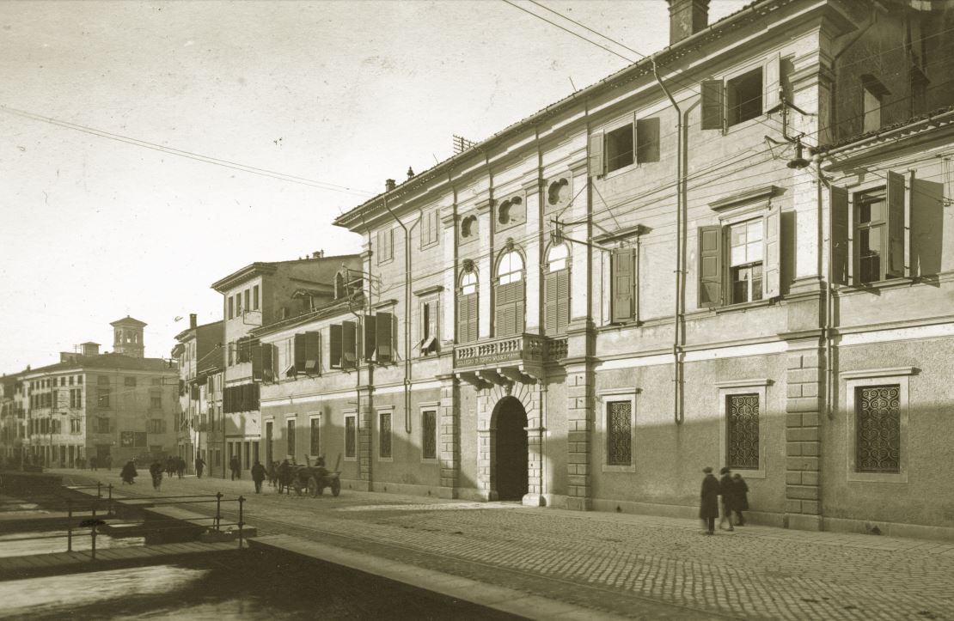
Figure 1. Udine - Palazzo Garzolini - Di Toppo Wassermann. Captions of the Figures should be placed below the image with 10pt font

Bibliography
[1] Author_1 A. B. , Author_2 C.D , … Author_final X.Y. Title of the article/review/book, J. Abbr. , year, volume(issue), start page - end page
[2] Author_1 A. B. , Author_2 C.D , … Author_final X.Y. Title of the article/review/book, J. Abbr. , year, in press, DOI
[3]
…

